**Report on Classifications of Network (LAN WAN MAN)**

**Network Classifications**

* Local Area Network (LAN)
* Wide Area Network (WAN)
* Metropolitan Area Network (MAN)
* **Local Area Network (LAN):**

**Introduction:**

A **local area network** (**LAN**) is a [computer network](https://en.wikipedia.org/wiki/Computer_network) that interconnects computers within a limited area such as a residence, school, laboratory, university campus or office building. By contrast, a [wide area network](https://en.wikipedia.org/wiki/Wide_area_network) (WAN) not only covers a larger geographic distance, but also generally involves [leased telecommunication circuits](https://en.wikipedia.org/wiki/Leased_line)

**History:**

The increasing demand and use of computers in universities and research labs in the late 1960s generated the need to provide high-speed interconnections between computer systems. A 1970 report from the [Lawrence Radiation Laboratory](https://en.wikipedia.org/wiki/Lawrence_Radiation_Laboratory) detailing the growth of their

"Octopus" network gave a good indication of the situation.

A number of experimental and early commercial LAN technologies were developed in the 1970s. [Cambridge Ring](https://en.wikipedia.org/wiki/Cambridge_Ring_(computer_network)) was developed at Cambridge University starting in 1974. [Ethernet](https://en.wikipedia.org/wiki/Ethernet) was developed at [Xerox PARC](https://en.wikipedia.org/wiki/PARC_(company)) between 1973 and 1974. [ARCNET](https://en.wikipedia.org/wiki/ARCNET) was developed by [Datapoint](https://en.wikipedia.org/wiki/Datapoint" \o "Datapoint) Corporation in 1976 and announced in 1977. It had the first commercial installation in December 1977 at [Chase Manhattan Bank](https://en.wikipedia.org/wiki/Chase_Manhattan_Bank) in New York.

**Wireless media:**

In a [wireless LAN](https://en.wikipedia.org/wiki/Wireless_LAN), users have unrestricted movement within the coverage area. Wireless networks have become popular in residences and small businesses, because of their ease of installation. Most wireless LANs use [Wi-Fi](https://en.wikipedia.org/wiki/Wi-Fi) as it is built into [smartphones](https://en.wikipedia.org/wiki/Smartphone), [tablet computers](https://en.wikipedia.org/wiki/Tablet_computer) and [laptops](https://en.wikipedia.org/wiki/Laptop). Guests are often offered [Internet access](https://en.wikipedia.org/wiki/Internet_access) via a [hotspot](https://en.wikipedia.org/wiki/Hotspot_(Wi-Fi)) service.

**Technical Aspect :**

[Network topology](https://en.wikipedia.org/wiki/Network_topology) describes the layout of interconnections between devices and network segments. At the [data link layer](https://en.wikipedia.org/wiki/Data_link_layer) and [physical layer](https://en.wikipedia.org/wiki/Physical_layer), a wide variety of LAN topologies have been used, including [ring](https://en.wikipedia.org/wiki/Ring_network), [bus](https://en.wikipedia.org/wiki/Bus_network), [mesh](https://en.wikipedia.org/wiki/Mesh_network) and [star](https://en.wikipedia.org/wiki/Star_network).

Simple LANs generally consist of cabling and one or more [switches](https://en.wikipedia.org/wiki/Network_switch). A switch can be connected to a [router](https://en.wikipedia.org/wiki/Router_(computing)), [cable modem](https://en.wikipedia.org/wiki/Cable_modem), or [ADSL modem](https://en.wikipedia.org/wiki/ADSL_modem) for [Internet](https://en.wikipedia.org/wiki/Internet) access. A LAN can include a wide variety of other network devices such as [firewalls](https://en.wikipedia.org/wiki/Firewall_(computing)), [load balancers](https://en.wikipedia.org/wiki/Load_balancing_(computing)), and [network intrusion detection](https://en.wikipedia.org/wiki/Network_intrusion_detection_system).

**Range :**

They **range** from 100 Mbps to 1000 Mbps. In general, a **LAN** uses only one type of transmission medium, commonly category 5 coaxial cables. A **LAN** is distinguished from other networks by their topologies

**Advantages :**

* Costly resources such as printers can be shared by all of the computers. ...
* Central backing store can be provided in one place (the dedicated file server) so all work is saved together. ...
* Software can be shared, and upgrading is easier too.

**Disadvantages :**

* Rings provide the fastest form of local area networking. Network security can be a problem.
* If a virus gets into one computer, it is likely to spread quickly across the network because it will get into the central backing store.
* Users of the network have to have user names and passwords.

**A conceptual diagram of a local area network (LAN) :**

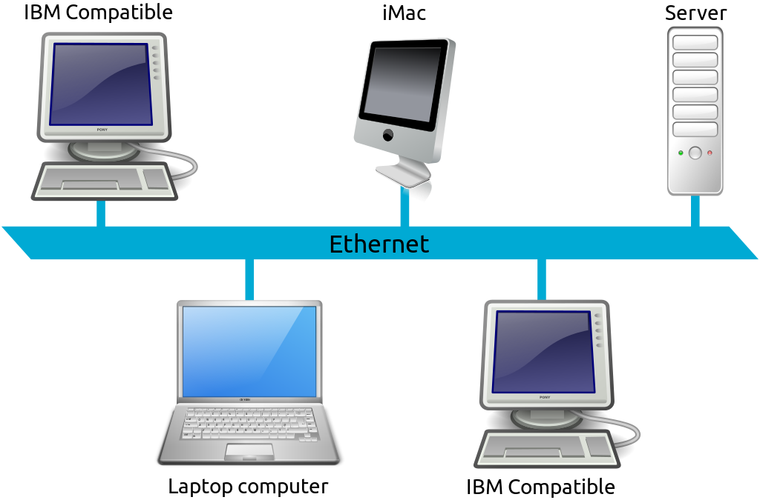

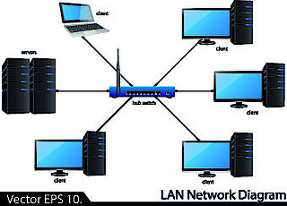

* **Wide Area Network (WAN)**

**Introduction:**

A **wide area network** (**WAN**) is a [telecommunications network](https://en.wikipedia.org/wiki/Telecommunications_network) that extends over a large geographical area for the primary purpose of [computer networking](https://en.wikipedia.org/wiki/Computer_network). Wide area networks are often established with [leased telecommunication circuits](https://en.wikipedia.org/wiki/Leased_line).

Business, as well as education and government entities use wide area networks to relay data to staff, students, clients, buyers and suppliers from various locations across the world. In essence, this mode of telecommunication allows a business to effectively carry out its daily function regardless of location. The [Internet](https://en.wikipedia.org/wiki/Internet) may be considered a WAN.

**Design Option:**

The textbook definition of a WAN is a computer network spanning regions, countries, or even the world. However, in terms of the application of computer [networking protocols](https://en.wikipedia.org/wiki/Communication_protocol) and concepts, it may be best to view WANs as computer networking technologies used to transmit data over long distances, and between different LANs, MANs and other localised computer networking architectures. This distinction stems from the fact that common LAN technologies operating at lower layers of the [OSI model](https://en.wikipedia.org/wiki/OSI_model) (such as the forms of [Ethernet](https://en.wikipedia.org/wiki/Ethernet) or [Wi-Fi](https://en.wikipedia.org/wiki/Wi-Fi)) are often designed for physically proximal networks, and thus cannot transmit data over tens, hundreds, or even thousands of miles or kilometers.

WANs do not just necessarily connect physically disparate LANs. A CAN, for example, may have a localized backbone of a WAN technology, which connects different LANs within a campus. This could be to facilitate higher [bandwidth](https://en.wikipedia.org/wiki/Bandwidth_(computing)) applications or provide better functionality for users in the CAN.

**Connection technology:**

Many technologies are available for wide area network links. Examples include [circuit-switched](https://en.wikipedia.org/wiki/Circuit_switching) telephone lines, [radio wave](https://en.wikipedia.org/wiki/Radio_wave) transmission, and [optical fiber](https://en.wikipedia.org/wiki/Optical_fiber). New developments in technologies have successively increased transmission rates. In ca. 1960, a 110 bit/s (bits per second) line was normal on the edge of the WAN, while core links of 56 kbit/s to 64 kbit/s were considered fast .As of 2014, households are connected to the Internet with [Dial-Up](https://en.wikipedia.org/wiki/Telephone_line), [ADSL](https://en.wikipedia.org/wiki/Asymmetric_digital_subscriber_line), [Cable](https://en.wikipedia.org/wiki/Cable_Internet_access), [Wimax](https://en.wikipedia.org/wiki/WiMAX), 4G or [fiber](https://en.wikipedia.org/wiki/Fiber-optic_communication). The speeds that people can currently use range from 28.8 kbit/s through a [28K modem](https://en.wikipedia.org/wiki/Dial-up_Internet_access) over a telephone connection to speeds as high as 100 Gbit/s over an Ethernet [100GBaseY](https://en.wikipedia.org/wiki/100_Gigabit_Ethernet) connection.

**Range:**

It range between 1 to 10000 kilometers. While a **WAN**, which operates similarly to a MAN, can span the globe, a MAN is only capable of spanning an area between 1 to 10000 kilometers in **range**.

**Advantages :**

* Covers large geographical area.
* Centralized data.
* Get updated files and data.
* A lot of application to exchange messages.
* Sharing of software and resources.
* Global business.
* High bandwidth.
* Distribute workload and decrease travel charges.

**Disadvantages :**

* Wide Area Networks faces more security problem as compare to LANs and MANs.
* One of the key **disadvantages of WANs** is a security issue when many different people have the ability to use information from other computers.

**A conceptual diagram of a Wide area network (WAN) :**

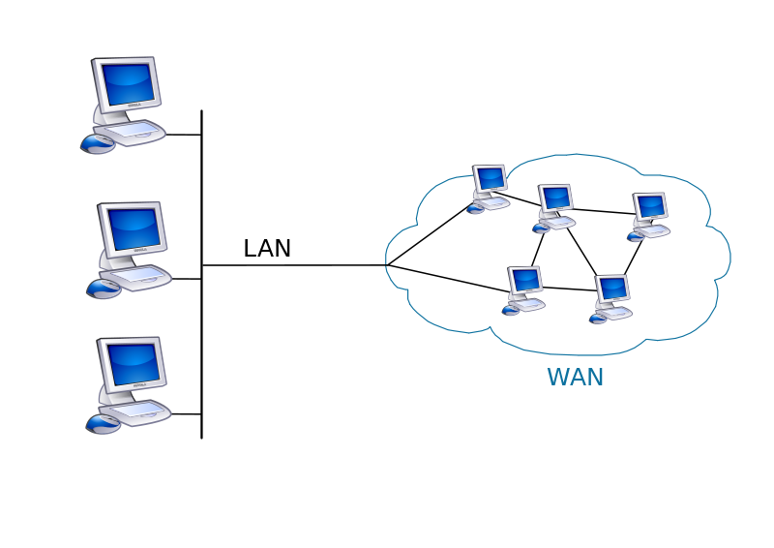

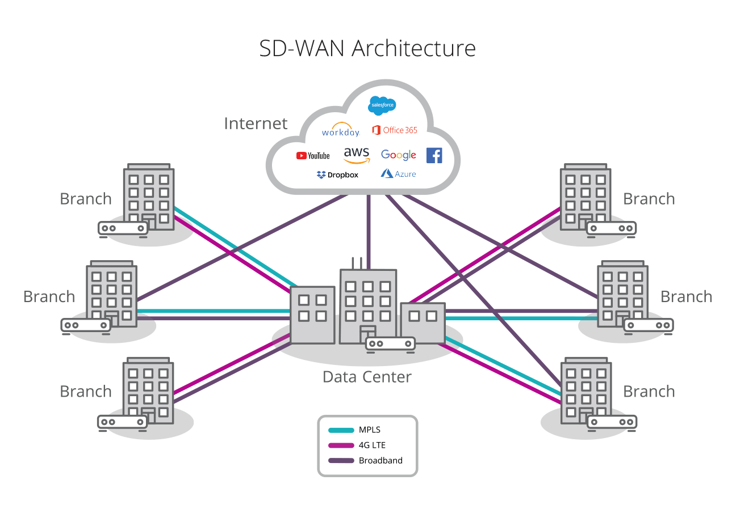

* **Metropolitan Area Network (MA**N):

**Introduction:**

A **metropolitan area network** (**MAN**) is a [computer network](https://en.wikipedia.org/wiki/Computer_network) that interconnects users with computer resources in a geographic region of the size of a [metropolitan area](https://en.wikipedia.org/wiki/Metropolitan_area). The term MAN is applied to the interconnection of [local area networks](https://en.wikipedia.org/wiki/Local_area_networks) (LANs) in a [city](https://en.wikipedia.org/wiki/City) into a single larger network which may then also offer efficient connection to a [wide area network](https://en.wikipedia.org/wiki/Wide_area_network). The term is also used to describe the interconnection of several local area networks in a metropolitan area through the use of [point-to-point connections](https://en.wikipedia.org/wiki/Point-to-point_(telecommunications)) between them .

**History:**

By 1994, [local area networks](https://en.wikipedia.org/wiki/Local_area_network) (LANs) were well established to provide data communication in buildings and offices. For the interconnection of LANs within a city, businesses relied primarily on the [public switched telephone network](https://en.wikipedia.org/wiki/Public_switched_telephone_network). But while the telephone network was able to support the packet-based exchange of data that the various LAN protocols implemented, the bandwidth of the telephone network was already under heavy demand from [circuit-switched](https://en.wikipedia.org/wiki/Circuit_switching) voice, and the [telephone exchanges](https://en.wikipedia.org/wiki/Telephone_exchanges) were ill-designed to cope with the traffic spikes that LANs tended to produce.

To interconnect local area networks more effectively, it was suggested that office buildings are connected using the [single-mode optical fiber](https://en.wikipedia.org/wiki/Single-mode_optical_fiber) lines, which were by that time widely used in long-haul telephone trunks. Such [dark fibre](https://en.wikipedia.org/wiki/Dark_fibre) links were in some cases already installed on customer premises and telephone companies started to offer their dark fibre within their subscriber packages. Fibre optic metropolitan area networks were operated by telephone companies as private networks for their customers, and did not necessarily have full integation with the public [wide area network](https://en.wikipedia.org/wiki/Wide_area_network) (WAN) through gateways.

The BERCOM MAN backbone could thus support two times 280 Mbit/s data transfer.

**Metropolitan internet exchange points:**

[Internet exchange points](https://en.wikipedia.org/wiki/Internet_exchange_point) (IXs) have historically been important for the connection of MANs to the national or global [Internet](https://en.wikipedia.org/wiki/Internet). The [Boston Metropolitan Exchange Point](https://en.wikipedia.org/wiki/Boston_Metropolitan_Exchange_Point) (Boston MXP) enabled metro Ethernet providers, such as the HarvardNet to exchange data with national carriers, such as the [Sprint Corporation](https://en.wikipedia.org/wiki/Sprint_Corporation) and [AT&T](https://en.wikipedia.org/wiki/AT%26T). Exchange points also serve as low-latency link between [campus area networks](https://en.wikipedia.org/wiki/Campus_area_network), thus the [Massachusetts Institute of Technology](https://en.wikipedia.org/wiki/Massachusetts_Institute_of_Technology) and the [Boston University](https://en.wikipedia.org/wiki/Boston_University) could exchange data, voice and video using the Boston MXP. Further examples of metropolitan Internet Exchanges in the USA that were operational by 2002 include the Anchorage Metropolitan Access Point (AMAP), the [Seattle Internet Exchange](https://en.wikipedia.org/wiki/Seattle_Internet_Exchange) (SIX), the Dallas-Fort Worth Metropolitan Access Point (DFMAP) and the Denver Internet Exchange (IX-Denver).

**Range:**

* It range between 5 to 50 kilometers.
* **MAN**: **MAN** is Metropolitan Area Network and is used to connect two or more LANs in a common geographic area: say a city or a group of buildings. MANs can span in the **range** of 5 to 50 kilometers in diameter.

**Advantages :**

* Less expensive: It is less expensive to attach **MAN** with WAN.
* Sending local emails.
* High speed than WAN.
* Sharing of the internet.
* Conversion from LAN to **MAN** is easy.
* High Security.

**Disadvantages :**

* Difficult to manage: It is very difficult to manage if the size and number of LANs network increase.
* Internet speed difference: As it cannot work on phone copper wires.
* Hackers attack.
* Technical staff requires to set up.
* Need More wires.

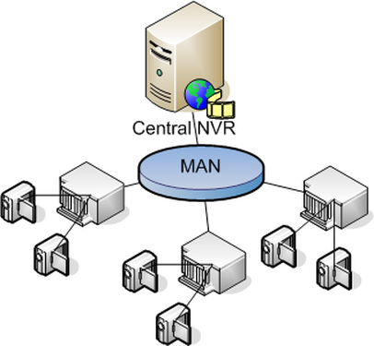**A conceptual diagram of a Metropolitan area network (MAN) :**

